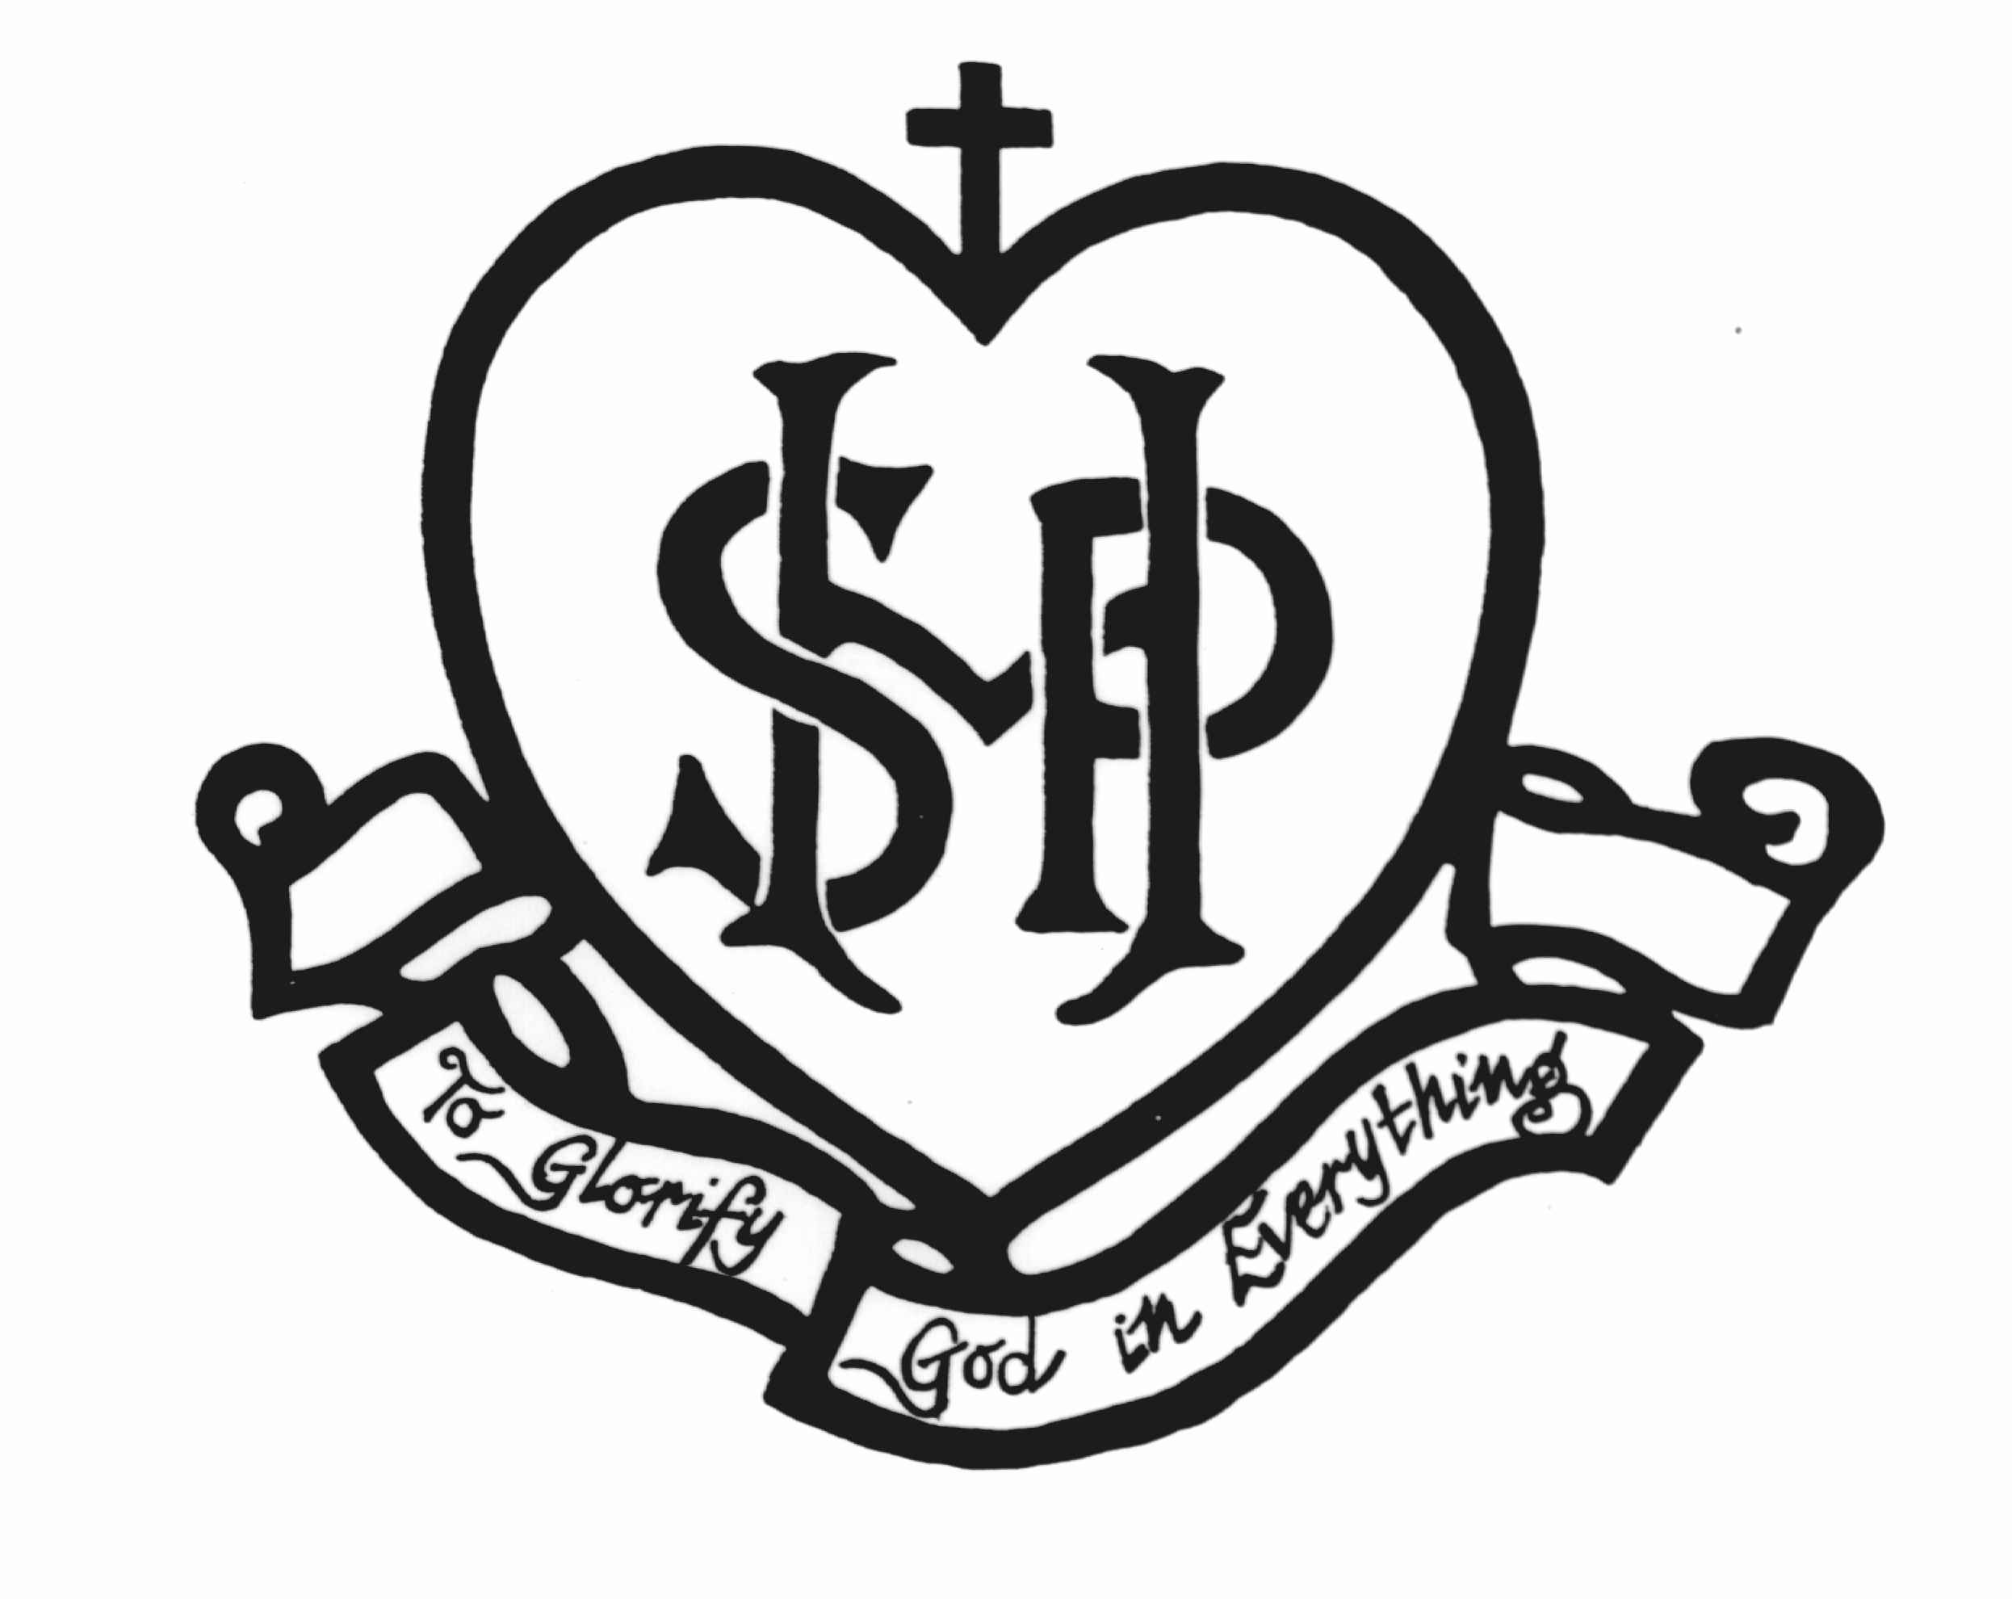

Enrolment Policy – Primary
Sacred Heart is a school which operates with the consent of the Catholic Archbishop of Melbourne and is owned, operated and governed by Melbourne Archdiocese Catholic Schools Ltd (MACS), where formation and education are based on the principles of Catholic doctrine, and where the teachers are outstanding in true doctrine and uprightness of life.

Enrolment principles
Our governing body, the MACS Board has established an agreed order of priority for enrolment which Sacred Heart School must follow.
Our first priority is the provision of a Catholic education for Catholic children.
While Sacred Heart is open to families of all faith and non-religious backgrounds, we aim and give priority to enrol Catholic and Orthodox children ahead of other Christian denominations, non-Christians or children of no religious affiliation.

Definitions
Parish: The local parish as defined by the Catholic Archdiocese of Melbourne.
Enrolment catchment area: A defined area from which a School enrols students as officially designated to a School by the MACS Board. Our catchment area is Sacred Heart Preston Parish boundary .
Catholic: A child is considered Catholic if they have been baptised and can provide a Certificate of Baptism from a Catholic Parish.
Orthodox: Includes children from non-Catholic Eastern churches. That is, Greek Orthodox, Coptic Orthodox, Ukrainian Orthodox, Russian Orthodox, Serbian Orthodox and Other Orthodox.

Enrolment priorities
Our order of priority for enrolment has been approved by our governing body, the MACS Board. The Board requires Sacred Heart to follow this Enrolment Policy.
Our order of priority is:
1) Children with a familial relationship:
a) siblings of children who are enrolled at, or have previously attended the school
b) daughters/sons of former students
2) Children who are residents of the school catchment and are in order of preference:
a) Catholic
b) Orthodox
c) Other Christian
d) Non-Christian
e) Of no religion

3) Children who are not residents of the school catchment, are unable to access the local Catholic primary school in their parish of residence, and are in order of preference:
a) Catholic
b) Orthodox
c) Other Christian
d) Non-Christian
e) Of no religion
Enrolment is subject to the maximum capacity of the School.

Application for enrolment
We strive to be welcoming and inclusive and to collaborate with parents as partners in the education of their child, while making every effort to ensure a Catholic education is accessible to every Catholic family through the provision of family-friendly fee policies and fee relief.
We are open and welcoming to all Catholic students, regardless of their background, and do everything reasonable to accommodate the individual needs of each student.
The MACS Board encourages and supports its schools to extend particular assistance to children who are poor, disadvantaged or considered most at risk.
Parents who wish to accept a place in a MACS school for their children will be required to agree and sign an Enrolment Agreement with MACS, represented by the Principal, for enrolment at the particular School.
We are required to collect and retain particular information about parents and their child in accordance with this Framework. Parents are required to provide particular information about their child during the enrolment procedure in order for our governing body to meet its duty of care obligations and to satisfy government requirements. Lodging an Enrolment Form does not guarantee enrolment at the particular School.

