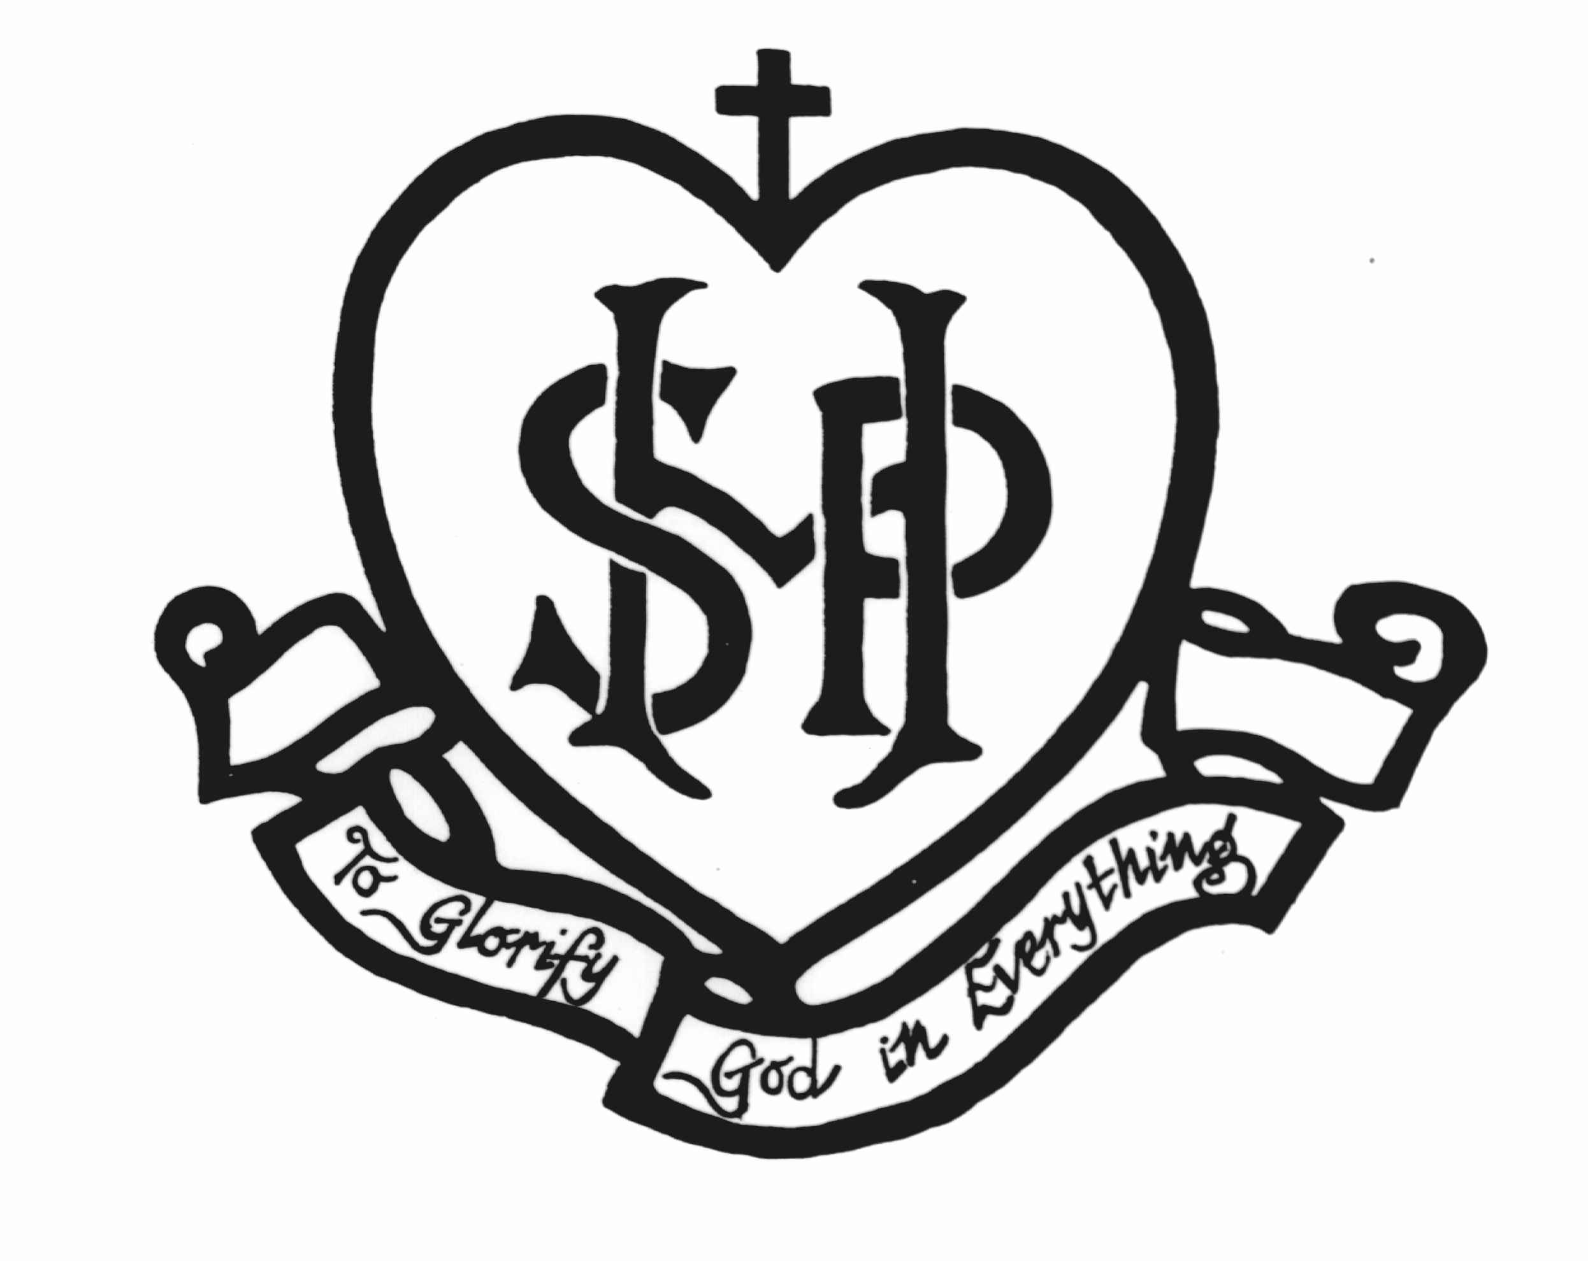

Sacred Heart School Parent / Guardian / Carer Code of Conduct
Sacred Heart is a school which operates with the consent of the Catholic Archbishop of Melbourne and is owned, operated and governed by Melbourne Archdiocese Catholic Schools Ltd (MACS), where formation and education are based on the principles of Catholic doctrine, and where the teachers are outstanding in true doctrine and uprightness of life.

Purpose
Sacred Heart School is committed to ensuring a respectful learning environment that is safe, positive and supportive for all students, staff and visitors of the School.
It is the intention of Sacred Heart School to provide clear guidelines to all parents and visitors regarding the conduct expected of them whilst on the School premises, engaging in School related activities or representing the School. Parents/guardians and visitors are expected to uphold the School’s core values at all times.

Application
This Code applies to all Sacred Heart parents and visitors to the School. The application of this Code is not limited to the School site and School hours. It extends to all activities and events that are school-related and when visiting or representing the School, including without limitation at all times when wearing the School uniform. The Code also requires that parent/guardian or visitor actions do not bring the School into disrepute at any time regardless of whether the action occurs within or outside of School activities.

Definition of a ‘Parent' and 'Visitor’
For the purposes of this policy, ‘Visitor’ of Sacred Heart School includes anyone visiting the School who is not a current student or employee. Reference to ‘Parent’ includes ‘Guardians and Carers’.

Basic Principles
This Code of Conduct is based on the following Principles that everyone at Sacred Heart School:
has the right to be safe
has the right to be treated with respect and be valued even in disagreement
has the right to participate within a secure environment without interference, intimidation, harassment, bullying or discrimination
is encouraged to be respectful, polite, courteous and considerate of others
has the right to be supported and challenged as ongoing learners.

Expected Conduct and Bearing of All Parents and Visitors
It is expected that every parent and visitor will:
uphold the School’s core beliefs and values
behave in a manner that does not endanger the health, safety and wellbeing of themselves or others
abide by all health and safety rules and procedures operating within the School and other locations at which they may visit whilst representing the School
ensure that their actions do not bring the School into disrepute
respect School staff and accept their authority and direction within the exercise of their duties at the School
observe all School rules as required
strictly adhere to the School’s policies and procedures as required
behave with respect, courtesy and consideration for others
refrain from all forms of bullying and harassment
refrain from any form of verbal insult or abuse and from any form of physical abuse or intimidation
refrain from activities, conduct or communication that would reasonably be seen to undermine the reputation of the School, employees or students of the School (including activities on social media);
respect School property and the property of staff, contractors, volunteers and other students
not be intoxicated by alcohol or under the influence of illicit drugs or other substances harmful to health whilst visiting the School site, attending School functions or engaging in School based activities
respect school staff and accept their authority and direction within the exercise of their duties at the School
use the School’s Complaints Handling Policy to seek resolution for any problems that arise, and accept the school’s procedures for handling matters of complaint.

Unacceptable Conduct
Unacceptable conduct includes, but is not limited to:
touching, handling, pushing or otherwise physically or sexually engaging with students, children or others in a manner which is not appropriate and may endanger the health, safety and wellbeing of that person
any form of physical or verbal violence including fighting, assault or threats of violence
approaching a child that is not your own with a view to disciplining that child for their behaviour (such matters are only to be dealt with by school staff)
approaching other school parents to resolve issues arising between students at school (such matters should be referred to school staff)
any form of cyber bullying or cyber abuse that is directed towards the school, staff members, students or parents or any member connected to the School
any form of threatening language, gestures or conduct
language or conduct which is likely to offend, harass, bully or unfairly discriminate against any student, employee, contractor, volunteer or other
theft, fraud or misuse of School resources
the use of inappropriate or profane words or gestures and images
visiting School, attending social, sporting or other functions whilst intoxicated by alcohol or under the influence of illicit drugs or other substances harmful to health
smoking on the School premises or within the immediate environs of the School
claiming to represent the School in any matter without explicit permission from the School Principal to do so.

Breach of the Code of Conduct
Parents and visitors who breach the Code of Conduct will be contacted by the School Principal. Appropriate action, which may include being banned from coming onto School grounds, attending School functions or School based activities, is at the discretion of the School Principal.
Parents who continually breach the Code of Conduct will be referred to the Principal, who has full discretion to take action which may include termination of this enrolment agreement.
In accordance with applicable legislation and the School’s Child Protection Policy, the Police and/or Department of Human and Health Services will be informed of any unlawful breaches of this Code.

NAME OF PARENT / GUARDIAN / CARER | Signature | Date:

